Ideation Phase
Brainstorm & Idea Prioritization Template

Date | 7 NOVEMBER 2025
Team ID | NM2025TMID06700
Project Name | Medical Inventory Management
Maximum Marks | 4 Marks

Medical Inventory Management Template:

The Medical Inventory Management System in Salesforce is designed to streamline the tracking and management of medical supplies, medicines, and equipment across healthcare facilities. It helps maintain accurate stock levels, monitor expiry dates, and ensure timely reordering from suppliers. The system stores detailed information about each item, including batch number, quantity, and storage location. Automated alerts notify users when stock levels are low or items are nearing expiration. Purchase orders and supplier details are managed efficiently within Salesforce. The solution enables seamless record-keeping, reducing manual errors and improving operational efficiency. Reports and dashboards provide real-time insights into inventory usage and availability. The system ensures compliance with healthcare standards and supports data-driven decision-making. Overall, it enhances patient care by ensuring the availability of essential medical resources at all times.

Step-1: Team Gathering, Collaboration and Select the Problem Statement:
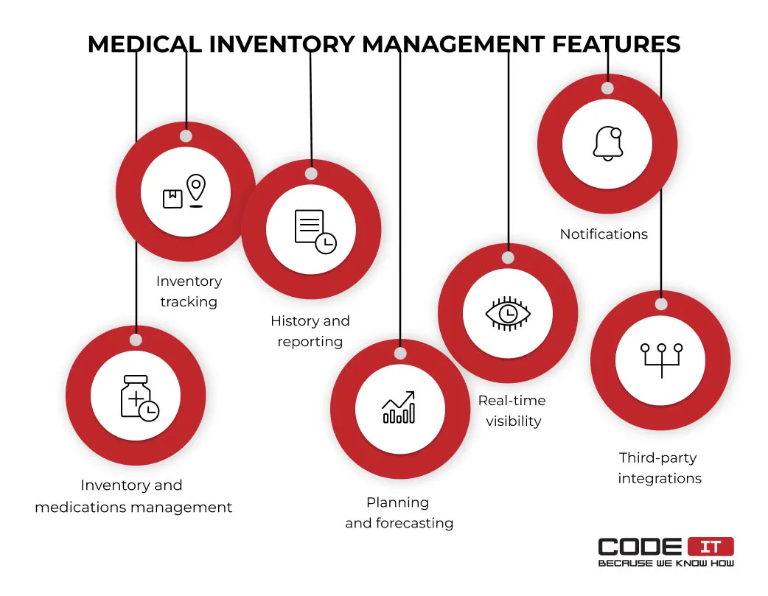
Step-2: Brainstorm, Idea Listing and Grouping:

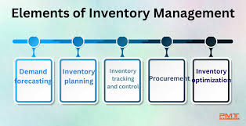

Fig2: Image that describes the work done by teammates.

1. Brainstorm:
Team members share ideas freely to explore solutions without judgment, encouraging creativity and participation.

2. Idea Listing:
All ideas from the session are written down to capture every suggestion and ensure no input is overlooked.

3. Grouping:
Similar ideas are organized into categories to identify patterns, highlight priorities, and simplify decision-making.

4. Action Planning:
Chosen ideas are turned into clear steps with assigned responsibilities and timelines

Step-3: Idea Prioritization:

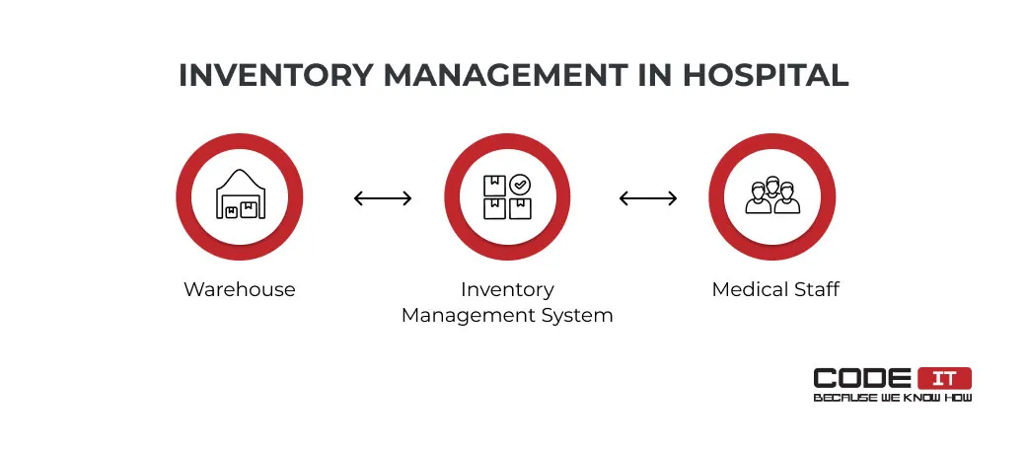
Fig3: Image of steps to prevent user deletion.

Idea Prioritization:

The idea prioritization for the Medical Inventory Management System focuses on addressing the most critical challenges faced by healthcare organizations in managing medical supplies. The top priority is ensuring real-time tracking of inventory to prevent stockouts and overstocking. Next, emphasis is placed on automated expiry date alerts to minimize wastage and ensure patient safety. Integration of supplier management and purchase order tracking is prioritized to streamline procurement processes. Data accuracy and automation are key to reducing manual errors in stock updates. The development also prioritizes user-friendly dashboards for quick decision-making and performance monitoring. Security and compliance are considered essential to protect sensitive medical data. Finally, the system aims to enhance efficiency, transparency, and cost control within healthcare inventory operations.

